Personnel Committee
Presbytery of Southern New England
May 4, 2024

For Information:

- Personnel has approved Shannan’s sabbatical. This will be a three-month sabbatical running from October 27, 2024 through February 15, 2025. The Committee will work with Shannan to identify converge for the period she is away.

- Stated Clerk (Kate) will be attending GA this summer.

- Mark Montgomery will represent Personnel and serve on the 2025 budget committee.

- Staff conversations continue and Personnel will meet again as a mid-year check point in June.

Respectfully submitted,

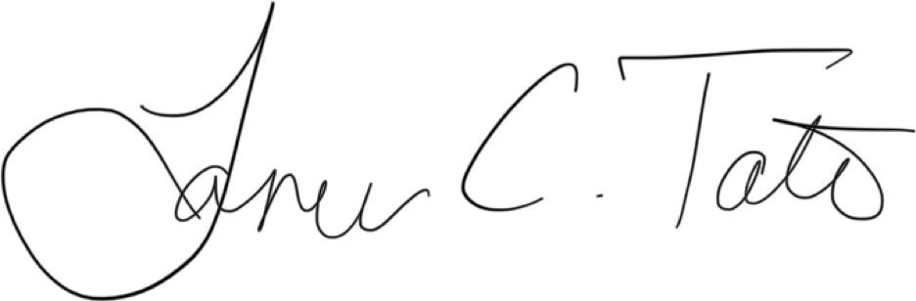

Lauren Tate, Chair

