Search and Call Tools for Congregations
Advancing the Spirit’s guidance into God’s future

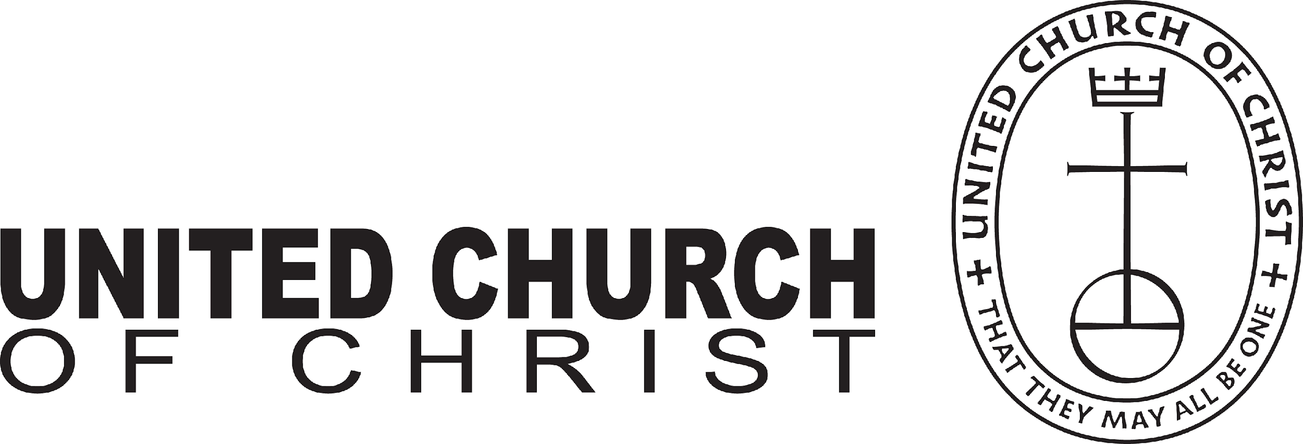
Who
is our neighbor

Who
are
we

Rachel Hackenberg
Microsoft
[Pick the date]

The new Local Church Profile is not just for congregations in search of a pastor. All congregations are encouraged to engage in its process of discovery every 3-5 years. The UCC Local Church Profile reflects valuable data, assesses ministry, clarifies change, and helps advance the calling of the congregation. Not just to be completed by a search committee – the more participation, the better!

MINISTERIAL EXCELLENCE, SUPPORT & AUTHORIZATION

Who is
God calling us to become

INTRODUCING THE NEW
LOCAL CHURCH PROFILE

?

UNITED CHURCH OF CHRIST
LOCAL CHURCH PROFILE

First Congregational Church of East Longmeadow/UCC
East Longmeadow, MA

Settled Pastor- Part Time

Southern New England Conference United Church of Christ

April 2024

LOCAL CHURCH PROFILE CONTENTS
- Position Posting
- Who Is God Calling Us To Become?
- Who Are We Now?
- Who Is Our Neighbor?
- References
- Consent and Validation

“God is able to provide you with every blessing, so that
having all sufficiency in all things at all times,
you may abound in every good work.”
(2 Corinthians 9:8)
INSTRUCTIONS

The new Local Church Profile supports the calling and discernment of United Church of Christ congregations with their current or future pastoral leadership.

For many congregations, the interim time between ministers is an intentional season that is guided in part by the preparation of a Local Church Profile. Using the Profile, the church can discover its data and express its story for the reliable discernment of a search committee and the beginning of a new pastorate. Searching ministers will want to see this document in its entirety.

The interim season is not the only time in a church’s life when it’s valuable to give attention to explore a congregation’s vocation. Three sections of the Local Church Profile – WHO ARE WE NOW, WHO IS OUR NEIGHBOR, and WHO IS GOD CALLING US TO BECOME – are meant to be updated every 3-5 years. Known together as the “Discovery Document,” these three sections can be completed by a visioning group, a governing body, a transition team, or other group – not just the search committee – in order to draw forward the gifts and imaginative possibilities of a congregation. The church’s engagement with the “Discovery Document” might not have the same sequence as the completed Local Church Profile that is read by candidates.

Some questions are easy to answer. Some are not so easy. Prompts are provided to stimulate narrative response if needed; these italicized prompts are merely examples from which to choose or to inspire your own. Efforts to answer the questions will prompt conversations and explorations and story-tellings and many prayers. As the Spirit moves throughout the process, congregations will shape a collective articulation of Christ’s leading (WHO IS GOD CALLING US TO BECOME). This last question to be answered becomes the first section to be read by searching ministers in the Local Church Profile, and it is the boldest and most actionable piece for faithful leadership into the future.

Your conference can provide materials referenced in the Local Church Profile, such as the 11-Year Report containing data as reported by your congregation annually to the UCC Data Hub, and Mission InSite reports containing demographic information on your community. More information on types of _{pastorate} in the United Church of Christ can be found in the Call Agreement Workbook. Be sure to use the Call Agreement Workbook’s Scope of Work to describe in this Local Church Profile the position being sought.

When it is time for ministerial search, the conference can counsel you on posting the Local Church Profile together with your public listing at UCC Ministry Opportunities (http://oppsearch.ucc.org).

The last page of the Local Church Profile contains a statement that parallels the consent statement signed by ministers in the UCC Ministerial Profile. In keeping with the covenantal relationship between a church and those it seeks to call, this statement encourages an open, honest exchange of information. On behalf of the United Church of Christ, and on the basis of the best knowledge available to them, your conference staff will validate your completed Local Church Profile when it is ready to be shared in relationship with prospective new leaders.
1. POSITION POSTING
a. LISTING INFORMATION

b. SCOPE OF WORK
c. COMPENSATION & SUPPORT
d. WHO IS GOD CALLING TO MINISTER WITH US?

1a. LISTING INFORMATION

Church name: First Congregational Church of East Longmeadow/UCC
Street address: 7 Somers Road, East Longmeadow MA 01028
Supplemental web links: www.churchontherotary.org

Additional ecumenical affiliations (e.g. denominations, communions, fellowships): Hampden County Association of Churches

Conference: Southern New England Conference United Church of Christ
Association: Hampden Association
UCC Conference or Association Staff Contact Person: Terry Yasuko Ogawa, Area Conference Minister, Northwest Region

Summary Ministry Description:
In a short paragraph, reflect on where your church is going and what it might look like when you get there. What do you need to get there? Who are you seeking to join you on this part of your church’s faith journey?
The First Congregational Church of East Longmeadow, Massachusetts, United Church of Christ, is seeking a pastoral candidate for a part time, settled position.
Through God’s grace of discernment, we strive to assess and determine the future of expanding and preserving our core Christian beliefs, in support of our ministry and missions. The ability to continue to carry them out and what that may look like, is based on our capacity, in all regards. It is clearly dependent on our continual discernment and evaluation of community needs, available assets now and in the future, overall support from our congregation and partnership with the community at large. We are seeking a pastor who will join us in this mission, by working with us to address the needs, strategically evaluate our status and abilities and partner with us as we move forward with the overarching belief in Connection, Caring and Community. We seek a minister who is outgoing and eager to help us forge relationships in the community. We seek someone who will be a spokesperson for the congregation within the local clergy association and with secular organizations in town. The successful candidate will be eager to help us think creatively about the solutions presented by Partners and work with us to continue the work started by the workgroup and our DTM.
Our goal is to keep moving forward in our ministry and missions, while having the insight and strength to adapt, adjust and alter as needed, to accept the changes that must occur and to identify and prioritize exactly what that means for us.

Photographs:
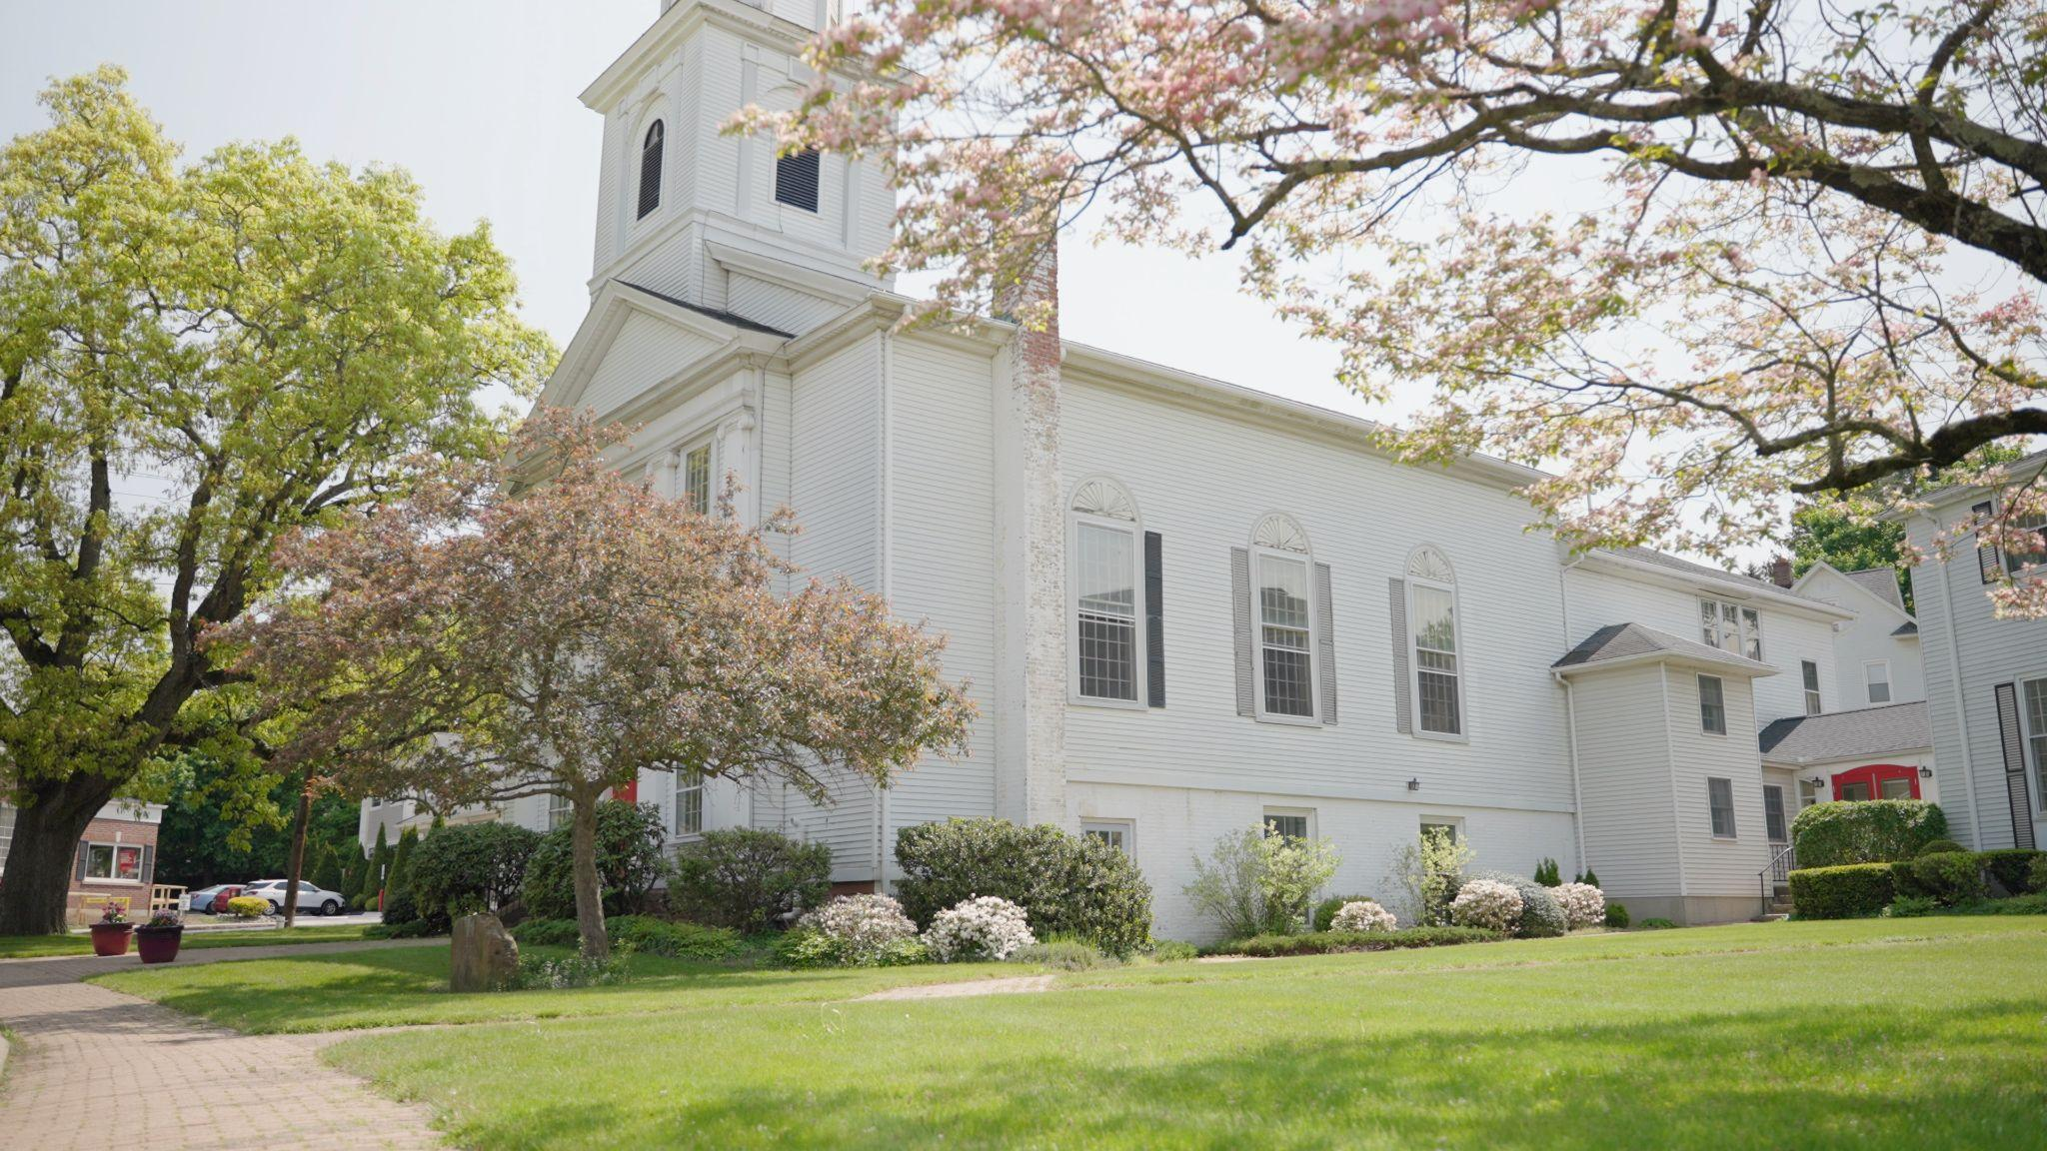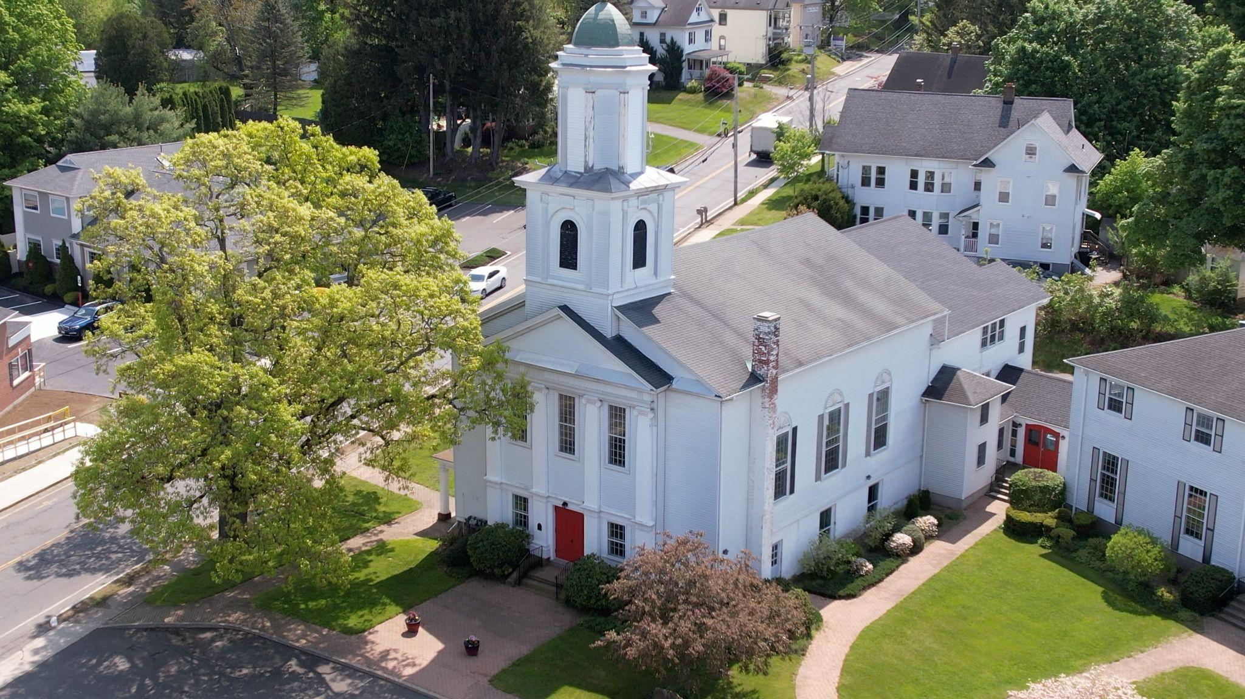

What we value about living in our area :
We value a true sense of community within our church as well as our church relationship with the greater community itself. The East Longmeadow community is representative of a New England suburban landscape.

Current size of membership: 207 members currently. The membership list was updated in 2021

Languages used in ministry (other than English): None

Position Title: Settled Pastor- Part Time

Position Duration (choose one, delete the other options listed):

Settled – a called position intended for longer-term ministry in which the minister moves church membership to the congregation and moves standing to related association.

Compensation Level:
½ Time

Does the total support package meet conference compensation guidelines? Yes

1b. SCOPE OF WORK
(add here the Scope of Work developed by your church using the Call Agreement Workbook)
Core Competencies:
(List three core competencies that you imagine could be foundational in your next minister’s relationship with the church. For example, a church seeking a pastoral care minister might hope to call someone who is caring, sensitive and sociable, while a church seeking an executive minister might want an organized, detail-oriented and time-conscious person.)

List a trait and explain why.
Caring: We are seeking a minister who is caring for the liturgy of our faith based Christian beliefs, our congregation and a willingness to work with us on our growth.

Organized: We are seeking a minister who is organized and detail oriented to lead our church through our journey of discerning and discovering, work with us through collaborative efforts to further our missions, enhance our community engagement and propagate our value in the community.

Sociable: We are seeking a minister who is outgoing and responsive to the needs of a congregation that has a large demographic of people who have been in the church for many decades, as well as a renewal of young families. Currently we are working to reconstitute our Sunday school and in many ways reinventing what that looks like. Our approach is to listen to what we see, hear and feel the needs of our younger generation and adapt the programming as it seems appropriate.

Preaching: Faith inspired messages to carry with us into our daily lives and into the world.

1c. COMPENSATION AND SUPPORT
Salary Basis (from the Call Agreement Workbook, equal to Cash Salary plus Value of Parsonage/Housing Allowance): $50,000
Parsonage option: Annual value @$2500/mo equals $30,000/year
Housing allowance option: 30% of total cash salary equals $15,000/year

Benefits (choose one):
Salary plus Benefits: Salary $50,000
SS Offset $5,000
Pension $ 9,241

Optional Benefits: To be determined and discussed (health, dental, etc)

Our salary calculations for a ~1/2 time minister, are based on the median annual income for our area. Hampden County residents ($61,310/year) and East Longmeadow residents. The resulting median income is $76,888/year. Income information provided by DataUSA and MissionInsite reporting. This community has a small town feel while also being conveniently close to all shopping, entertainment and healthcare needs.

What is the expected living situation for your next minister (e.g. parsonage, living nearby with a housing allowance, living elsewhere to commute as needed)?
Housing / Allowance TBD based on minister’s needs.

Comment on the residential/commuting expectations for your next minister.
We have a parsonage that is located ~ 2 miles from the Church. If not needed by the candidate, we will consider a housing allowance. The parsonage is on a beautiful flat, corner lot with a fenced in area for kids or dogs and an area for gardening. We will also be doing some renovations and updating. The neighborhood is quiet and only a 10-minute drive to the church. The minister portion of utilities can be discussed.

State any incentives (e.g. school debt reduction or retention bonus after a certain number of years in position): Can be discussed.

Describe peer and professional supports available for ministers in your association/conference:
We offer a Ministerial Relations committee as well as a personnel committee which is open and available to the minister. The Hampden County Association has a peer pastoral group and the Southern New England United Church of Christ Conference provides incredible support through the area conference ministers, at a local level.

If applicable, describe how your church will adopt part-time adjustments in the pastoral schedule to support a minister’s bi-vocational employment: Can be discussed as necessary

1d. WHO IS GOD CALLING TO MINISTER WITH US?
Describe the ministry goals you envision your next minister co-collaborating with the congregation to achieve.
We are seeking a part-time settled minister to succeed in our transition from full time settled ministers to interim and designated term pastors.
We have just completed a three-part consultation service with Partners for Sacred Places. We started by developing a mission statement for our properties. We continued in conducting a large community engagement event that explored our church workings and how we interface with the greater community. Attendees also reviewed our church facilities and buildings. We continue to meet as a congregation to discern the next steps. The reports are available upon request.
While our church has been led under a traditional minister model, which met the cultural expectations in the past, we may need to come up with new ways to serve the needs in our community. While we are hopeful for growth post pandemic, we are realistic that our path may lead us in ways we can't yet imagine.

Describe how your vision of the minister you are now seeking will assist the congregation in making an impact beyond its walls.
Partners for Sacred Places (Partners) recommended that careful consideration be given to the importance of clergy leadership in community collaboration. The ability to imagine a future which might include out-of-the-box thinking about the property will be critical for forward momentum.

We will need a minister who is outgoing and eager to help us forge relationships in the community. We seek someone who will be a spokesperson for the congregation within the local clergy association and with secular organizations in town. The successful candidate will be eager to help us think creatively about the solutions presented by Partners.

Specify language requirements or culturally-specific capacities preferred in a next ministerial leader, and why those matter to the congregation’s sense of calling.

None noted

Based on what you have learned about who your church is, who your church’s neighbor is, and who God is calling the church to become, describe four areas of excellence from The Marks of Faithful & Effective Authorized Ministry that your next minister will display to further equip the congregation’s ministry in these areas.
Exhibiting a Spiritual Foundation and Ongoing Spiritual Practice
- Loving God, following Jesus Christ, and being guided by the Holy Spirit; living a life of discipleship.
- Praying actively and nurturing spiritual practices.
- Being called to ordained ministry by God and the Church.
- Continuing discernment of one’s call in the community.
- Understanding the power of the Holy Spirit at work through the elements of Christian worship to nurture faith.
- Exhibiting a commitment to lifelong spiritual development and faithful personal stewardship.

Building Transformational Leadership Skills
- Empowering the Church to be faithful to God’s call, reflective of Christ’s mission, and open to the surprises of the Holy Spirit.
- Strategically creating the future of God’s Church.
- Witnessing in the public square to God’s redeeming power.
- Performing necessary and appropriate administrative tasks.
- Working collaboratively with intercultural awareness and sensitivity.
- Encouraging leadership development of self and others through continuing education and lifelong learning.
Engaging Sacred Stories and Traditions
- Exhibiting knowledge, understanding, and continuing study of the Hebrew Scriptures and the New Testament.
- Maturing in effective proclamation and preaching.
- Understanding the history of the Christian Church, from biblical times forward.
- Bringing life to sacred stories and traditions in worship, proclamation, and witness.
- Leading faith formation effectively across generations.
- Holding the Holy with integrity especially as represented in the Sacraments.
Strengthening Inter- and Intra- Personal Assets
- Developing and maintaining a healthy sense of self as shaped by God, community, and life experiences.
- Living in relationships of covenantal accountability with God and the Church.
- Exhibiting strong moral character and personal integrity.
- Respecting the dignity of all God’s people.
- Understanding and ministering to stages of human development across the lifespan.
- Demonstrating excellent communication skills.

2. WHO IS GOD CALLING US TO BECOME?
“You shall love the Lord your God with all your heart, and with all your soul, and with all your mind.” (Matthew 22:37 NRSV)

Who is God calling you to become as a congregation?

- God is calling us to follow our church’s own history since 1829, to be the light of the world to the congregation and community. To follow Jesus’ teachings as an example of love, faith, hope and peace.
- God is calling us to light the way to Christian living, endless service to others, and be bound by common faith and covenant with Him.
- He calls us to be salt of the earth, to preserve and protect his love and teaching, and to obliterate hatefulness and sin through our example in the community.

Describe how God is calling you to reach out to address the emerging challenges and opportunities of your community and congregation.
For example, describe two experiments your congregation has initiated or engaged in the past year, what were the results and where do you see your next steps? Has your church had a multi-year strategic plan or vision statement; if so, where do you see that plan/vision taking you?
We worked with Partners for Sacred Places over the past year to create the framework and foundation to build our future as a congregation and our role in our community.

Our next step is to cultivate a deeper understanding of the congregation’s mission and vision, particularly in reference to the future of its buildings and property. Our group engaged in a focused process to examine this and now needs to take action. Partners for Sacred Places guided us to develop a strategic vision and plan for long-range stewardship of our buildings. These options will consider the current mission and vision statements of First Congregational Church and engage us in acting on them for the current situation of the congregation.

It was determined that we sell a property owned by us that has not been profitable and is a liability for the congregation. Another option to pursue is an anchor tenant to rent space in the Fellowship Hall.

This year we held a Food Truck event to raise money for the local Food Bank. This new community event was sparked by discussions with “Partners” and we hope to make this an annual community event.

We also continue to support our ongoing missions that include:
- Kensington School (an inner city elementary school) food pantry and tutoring
- Winter coat drive
- Loaves and Fishes
- Newborn baby quilt group
- YWCA Women's shelter
and we continue to search for new ways to serve our community

3. WHO ARE WE NOW?

“You shall love your neighbor as yourself.” (Matthew 22:39 NRSV)
a. CONGREGATIONAL REFLECTIONS
b. 11-YEAR REPORT
c. CONGREGATIONAL DEMOGRAPHICS
d. PARTICIPATION AND STAFFING
e. CHURCH FINANCES
f. HISTORICAL INFORMATION

3a. CONGREGATIONAL REFLECTIONS ________
Describe your congregation’s life of faith.
For example, what beliefs and commitments are stated in your congregation’s purpose statement or membership vows? How is God most often described in worship liturgy? In what ways would you describe the Holy Spirit in your midst?

- Our beliefs and commitments incorporate connection, caring and community.
- God is most often described in the masculine for worship and prayers.
- The Holy Spirit guides us in our choices, opening us up to other ideas, giving us peace in our thoughts and actions.

“We the First Congregational Church of East Longmeadow, U.C.C., in response to the Gospel of Jesus Christ, strive to be a welcoming community. As an Open and Affirming Church, we accept all people into our faith community, regardless of age, gender, race, ethnicity, physical and mental abilities, socioeconomic status, sexual orientation, or gender identity and expression. We affirm the rights of all persons, just as Jesus affirmed the dignity of every human being as a child of God. Each person is invited and encouraged to participate in all aspects of our church life and ministry and to share in God’s love”. Adopted 1/7/2018

Describe several strengths or positive qualities of your congregation.

- We have a strong group of collaborative and engaged members. We have fewer members who want to lead efforts and decision-making.
- Very strong mission commitment
- Congregation is a true church family - not just strangers sitting in pews

Describe what worship is like when your congregation gathers.
For example, where does worship take place, and what is it based around? What was a recent baptism like? What are some words used to describe good preaching?
Worship takes place in a typical New England sanctuary. It is a traditional service with piano and occasional organ accompaniment. We provide special music at times throughout the year with instrumental and bell performances. Diversity is found in age and dress. The service is live streamed for remote participants. Caring is strengthened through the congregational sharing of prayers and celebrations.
Recent baptisms had parents and godparents present before the congregation. Gifts are given to the parents and have included: scallop shells, sand dollars, books, certificates and roses. The congregation always enjoys the walking introduction of the baptized child by the pastor.
Good preaching of a faith-based message that provides a relevant connection with life events, along with the presence of the Holy Spirit, carries us into our week.

Describe the educational program/faith formation vision of your church.
For example, how are young people in leadership? How do people continue to form their faith over a lifetime? Name a topic studied or curriculum used recently; what was the impact of this study on those who attended?
After many years of following the traditional Sunday School model, and PF/Youth group, declining numbers of young families and then the COVID pandemic, we no longer had any children in our program. Post pandemic, we have restarted our Sunday morning program with a one room schoolhouse approach, with ages of kindergarten, up to middle school aged children. We are fortunate to have between 2-6 children on any given Sunday with several young families represented. We have extensive resources available to us from previous years, but we are currently using the “All-in-one Sunday School”, published by Lois Keffer and Group publishing. Last year's program started with a fairly deep dive into the Exodus stories of Moses and the Hebrew people. This year we started digging into the new testament, not assuming any of the students had any knowledge of Jesus and will build from there.

Youth of confirmation age and older are welcome participants into the worship and we enjoy several teenagers/young adults that will read scripture etc. during worship. We struggle with maintaining connections with many of the youth once they graduate, but do have some that will participate from time to time. We are able to draw on some young adults that are always willing to help with mission projects (i.e. our church fairs, loaves and fishes etc).

Describe how your congregation is organized for ministry and mission.
For example, how are decisions communicated in your church? How are teams or committees organized? Where does your church struggle for vision?
When it comes to decision-making, how many hours are spent in meetings per month?
- Committees meet about 1 hour per month. Cabinet meets once a month, and important decisions are relayed to the congregation by weekly newsletter and/or from the pulpit.
- The minister is expected to attend the Board of Deacons meeting and Cabinet meeting.
- The Board of Deacons meets 1 hour per month, usually virtually, to discuss liturgical and ministerial matters that fall within the Deacons realm.
Think of a time when action had to be taken quickly, for example when a crisis or disaster occurred. How was that accomplished?
- There were a couple instances where the church had to make difficult decisions in response to crisis situations. One was the Covid shut down and another was severe flooding that ruined our boiler system. In both instances the Cabinet met in executive session very soon and made appropriate decisions on how to react and respond to the situations.
Can you provide the next minister with a copy of an organization structure, bylaws and/or annual report to further explain the patterns of the church’s activity and governance?
- [Yes/No] Yes - Annual Report, Annual Financial Report, Church ByLaws.

3b. 11-YEAR REPORT
(add here the 11-Year Report developed with the help of your conference staff, UCC Data Hub, and MissionInsite)
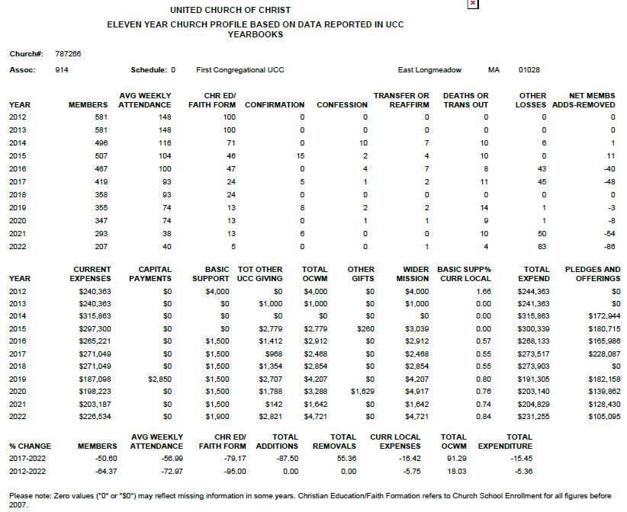

3c. CONGREGATIONAL DEMOGRAPHICS ____
Can gather from the Annual report
Describe those who participate in your church.
 |  | Is this number an estimate? (check if yes)
Number of active members: | 207
Number of active non-members: | 5 | yes
Total of church participants (sum of the numbers above): | 212

Percentage of total participants who have been in the church:
 |  | Is this numbere an estimate? (check if yes)
More than 10 years: | 75% | yes
Less than 10, more than 5 years: | 20% | yes
Less than 5 years: | 5% | yes
Number of total participants by age:
0-11 | 12-17 | 18-24 | 25-34 | 35-44 | 45-54 | 55-64 | 65-74 | 75+ | Are these numbers an estimate? (check if yes)
1% | 1% | 1% | 2% | 5% | 5% | 10% | 35% | 40% | yes
Note: The vast majority of our congregation is over 50. We have several families with young children who have returned since the end of COVID restrictions.

Percentage of adults in various household types:
 |  | Is this number an estimate? (check if yes)
Single adults under 35: | Unknown | *We do not gather this data
Households with minors: | Unknown
Single adults age 35-65: | Unknown
Joint households with no minors: | Unknown
Single adults over 65: | Unknown

Education level of adult participants by percentage:
 |  | Is this number an estimate? (check if yes)
High school: |  | We have a broad mix of educational and professional backgrounds
College:
Graduate School:
Specialty Training:
Other (please specify):

Percentage of adults in various employment types:
100% | Yes | Is this number an estimate? (check if yes)
Adults who are employed: |  | We do not gather this data
Adults who are retired: |  | Majority
Adults who are not fully employed: |  | We do not gather this data

Describe the range of occupations of working adults in the congregation:
We enjoy a mix of retired professional, current employed professional and professional tradespersons.

Describe the mix of ethnic heritages in your congregation, and the overall racial make-up. Most UCC congregations tend to describe themselves as “diverse.” Yet, the vast majority of UCC congregations are mono-cultural. What does diversity mean in your context?
We are representative of our community, which is a predominately white, middle class, suburban congregation. We present an open, welcoming, and affirming environment and welcome all who walk through our door.

Has your congregation recently had a conversation about welcoming diversity, or do you plan to hold one in the near future (perhaps using, for example, the Welcoming Diversity Inventory)? Please note the date.
We have not had a recent conversation about welcoming diversity. Our most recent experience with this was 2018 when we developed our Open and Affirming Statement.

3d. PARTICIPATION AND STAFFING
Complete the following chart. Please leave blank any fields that are not applicable to your congregation.
Ways of Gathering | Estimated number of people involved in attendance | Who plans each of the listed gatherings? (list any and all worship planners, such as various lay leaders, pastors, musicians, other staff)
Adult Groups or Classes
Baptisms (number last year) | 1 last year 3 this year | Deacons and Minister
Children’s Groups or Classes | ~2- 6 per sunday | We currently have one lead teacher with 6 assisting, so that we always have two adults in the classroom
Christmas Eve and Easter Worship | varies | Deacons and others
Church-wide Meals | ad-hoc | no longer do we hold scheduled pot luck dinners etc. Only done when a special event or activity is scheduled. (St Patrick's day dinner, Food truck event etc.)
Choirs and Music Groups | 1 choir | Music Director
Church-based Bible Study | none recently
Communion (served how often?) | Monthly | Deacons and Minister
Community Meals | once per month | We have 4 teams of volunteers. Each team has a leader and 6-8 volunteers that organize, prepare and serve a meal once per month at a local urban church that supports homeless and needy people of all ages.
Confirmation (number confirmed last year) | 3 | Interim Minister prepared and led the program
Drama or Dance Program | -
Funerals (number last year) | 5 | Minister
Intergenerational Groups
Outdoor Worship | Yes in the past | We held outdoor services during Covid, when applicable.
Prayer or Meditation Groups |  | Prayer groups were held this past year as we worked through the Partners process. The minister brought a prayer model that the congregation explored over a period of several months.
Public Advocacy Work
Retreats | 1 | The Minister took our Confirmands on retreat as part of their curriculum.
Theology or Bible Programs in the Community | -
Weddings (number last year) | 0
Worship (time slot: _______) | 10am | Regularly scheduled services are 10 am Sunday. Other services on holidays
Worship (time slot: _______)
Young Adult Groups or Classes
Youth Groups or Classes | -
Other
Additional comments:

List all members or regular participants in your congregation who are ordained, licensed, or commissioned ministers. Indicate those with current United Church of Christ Three-Way Covenants (i.e. serving in a congregation) or Four-Way Covenants (i.e. serving in a ministry beyond a congregation).
Name | Three- or Four-Way Covenant?  (3 or 4 or No) | Ministry Setting | Type of Ministry Role | Retired?  (Y or N)
If one or more previous pastors or retired ministers currently hold membership in the church, describe their role(s) in the life of the congregation:
List all current staff, including ministers. Exclude the position you are seeking to fill. Indicate which staff person serves as head of staff.
Staff Position | Head of Staff? | Compensation (full time, part time, volunteer) | Supervised by | Length of Tenure for current person in this position
Admin Asst | No | part time | Minister | 10+ years
Music Director | No | part time | Deacons | 3+
Bookkeeper | No | part time | Business and Finance | 10+

REFLECTION
Reflection: After reviewing the congregational demographics and activities above, what does this information reflect about your congregation’s overall ministry?
Our ministry is strong in Mission and Outreach programs, enhancing community awareness and engagement with secular groups and local government. We have a large demographic of aging congregants and also a growing number of younger people with young families.

3e. CHURCH FINANCES

Current annual income (dollars used during most recent fiscal year)
Source | Amount
Annual Offerings and Pledged Giving | $134,339.40
Endowment Proceeds (as permitted within spending policy, such as a cap of typically 4.5%-5% on total return) | $
Endowment Draw (beyond what is permitted by spending policy, “drawing down the principal”) | $
Fundraising Events | $ 17,073.31
Gifts Designated for a Specific Purpose | $
Grants | $
Rentals of Church Building | $ 30451.72
Rentals of Church Parsonage | $
Support from Related Organizations  (e.g. Women’s Group) | $
Transfers from Special Accounts | $ 30,000
Other (specify): | $
Other (specify): | $
TOTAL | $211864.43

Current annual expenses (dollars budgeted for most recent fiscal year): $226,533.85
Attach most recent church budget, spending plan, operating statement, or annual treasurer’s report as shared publicly with the congregation, or – if your church does not pass an annual budget – list current budgeted expenses here.
See below:
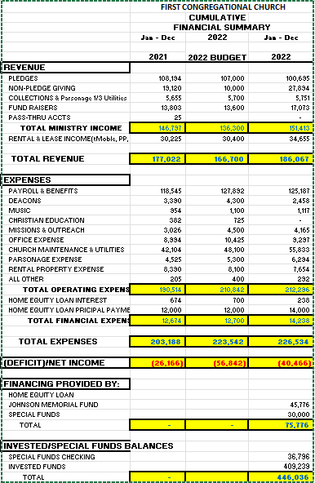

Considering total budgeted expenses for the year, compare total ministerial support. What is the percentage? 22%

Has the church ever failed to pay its financial obligations to a minister of the church? No

Is your church 5-for-5, i.e. does it include each of the following contributions during the church year? (indicate those included during the most recent fiscal year)
_x_ Our Church’s Wider Mission (OCWM – Basic Support)
_x_ One Great Hour of Sharing
_x_ Strengthen the Church
_x_ Neighbors in Need
_x_ Christmas Fund

In what way is OCWM (Basic Support) gathered? If calculated as a percentage of the operating budget, what is that percentage? (recommended 10%) 1%

What is the church’s current indebtedness?
Total amount of loan debt: $0.00
Reason for debt:
Are capital and other payments current?

If a building program is projected or underway, describe it, including the projected start/end date of the building project and the total project budget.

If the church has had capital campaigns in the last ten years, describe:
Year(s) | Purpose | Goal | Result | Impact
2021 | Replace Boiler | $14,000 | $12,200 | Defrayed cost for the boiler.
 |  | $ | $
If a capital campaign is underway or anticipated, describe:
Year(s) | Purpose | Goal | Result | Impact
 |  | $ | $
 |  | $ | $
Describe the prominent mission component(s) involved in the most recent (or current) capital campaign.

Does your church have an endowment? YES

What is the market value of the assets? $464,260

Are funds drawn as needed, regularly, or under certain circumstances?
As needed

What is the percentage rate of draw (last year, compared to 5 years ago)?
Last year $30,000, 5 years ago we withdrew $51,000

Describe draw on endowment, if any, to meet operating budget expenses for the most recent year and the past five years:
- 2018 - $51,000
- 2019 - $5,000
- 2020 - $0
- 2021 - $0
- 2022 - $30,000

At the current rate of draw, how long might the endowment last?
15 years if including restricted funds.

Please comment on the above calculations or estimates:
Assumed same withdrawal rate over time and this includes access to restricted funds.

Other Assets

Reserves (savings): $0
Investments (other than endowment): $
Does your church have a parsonage? Yes

Fair market rental value of the parsonage: $2,500/month ESTIMATED due to local rental market fluctuations
How is the parsonage used? Pastor’s residence
Street / City / State / Zip: 239 Porter Road East Longmeadow, MA 01028
Finished square footage: 1447sq. ft
Number of Bedrooms, Number of Bathrooms: 4/2
Assessed real estate value: $358,300
Available for minister residence: Y/N Yes
Expected minister residence: Y/N TBD
Condition of structure, systems and appliances – Some updating will occur prior to new residents.
Entity in the church responsible for review and needed repairs – Board of Business and Finance

Describe all buildings owned by the church:
- Parsonage- 239 Porter Road, E. Longmeadow MA
- Church- 7 Somers Road, E. Longmeadow MA also includes the Fellowship Hall and education building
- Carriage house- 50-58 Prospect Street

Describe non-owned buildings or space used or rented by the church:
none

Which spaces are accessible to wheelchairs? (worship space, pulpit, fellowship space, facilities, etc.)
- Sanctuary
- Fellowship Hall

Reflection: After reviewing the church’s finances and assets described above, what does this information reflect about your congregation’s mission and ministry?
For example, when was a time the church made a major budget change? How is the budgeting process done? What new ministry initiative has your church financed?

- Committee chairs submit to B&F
- We are reactive to critical needs, meeting expenses but not much extra to expand missions further than current levels

3f. HISTORICAL INFORMATION
Name one to three significant happenings in the history of your church that have shaped the identity of your congregation. Add the most important event in the life of your church in the past 10 years
- One of the most important events in the life of the congregation over the past 10 years would be the fact that it become totally clear, that with the financial path we are on, we have a limited number of years (10-15), before we would have to face the inevitable elimination of staff and ultimately closure of our church facility. In a bold move, in the summer of 2023, the congregation contracted with (and invested in) “Partners for Sacred Places” to conduct a Discovery Study as part of a larger project to identify opportunities for the Churches continued presence in the town of East Longmeadow. With a long history that started in the 1800’s, we found ourselves with waning membership, escalating costs and a shrinking endowment. Because of the recognition of the impact that this congregation, its members and its facilities have had to the overall town, we decided we would invest a substantial amount of our assets, to work with Partners, with the hope of finding a way to ensure the congregation's presence would be felt for many years into the future. After much work with town stakeholders and non-members, who shared valuable input as to the value they saw in us and provided many ideas for the congregation to follow up on. We received a Discovery phase report from Partners in the fall of 2023 and are continuing the process as of this writing (10/23/23).
- Response to Covid: We started with outdoor services using a camera and starting streaming. As it got colder we remotely recorded pieces of the service in our homes and edited the pieces together into one worship service. Once we could again access the sanctuary we invested in video streaming equipment and began formally streaming via Facebook live.

Describe a specific change your church has managed in the recent past.

For example, what is an example of a recent conflict and something your congregation learned from it? Describe an occasion when your church experienced conflict without being able to resolve it well. Does your church have policies, protocols or structures for dealing with conflict?)

The congregation does a good job of respecting the rights and viewpoints of all its members. We use small and large group meetings to move forward ideas and proposals. We then hold all church meetings that are announced well ahead of the vote and each member is entitled to one vote on the issue. Our leadership uses parliamentary procedures to conduct the meetings.
Example:
- The congregation looked into becoming Open and Affirming in 2014. There was much discussion and we lost some members during and after the decision to become Open and Affirming. The minister at that time did not support our decision. The congregation held multiple open meetings to discuss the proposed changes and ensured that everyone was able to participate in what could have been a contentious discussion. The meetings culminated in an all church meeting/vote to adopt the Open and Affirming label as outlined by the UCC.

Ministerial History (include all previous ministerial staff for the past 30 years)

Staff member’s name | Years of service | UCC Standing (Y/N)
Rev. Robert Kyte (Settled) | 1984-1988 | y
Rev. Robert Gormbley (Settled) | 1995-2007 | y
Rev. Edward Babinsky (Interim)  Rev. John Tipton (Settled)  Rev. Carrie Bail (Interim)  Rev. Dr. William Wildman (Settled) | 2008-2010  2011-2014  2014-2016  2016-2018 | y  y  y  y
Rev. Dr. Philip Mayher (Bridge)  Rev. Carrie Bail (DTP) | 2018-2020  2020-2023 | y  y

Comment on what your church has learned about itself and its relationship with persons who provided ministerial leadership:
We have been trying to secure a permanent settled part-time pastor for a while. Over the past few years, the members of the congregation have stepped up to the plate in so many ways demonstrating their love of, and commitment to our congregation. Members have filled the pulpit on many occasions over the past few years. We have many groups of people that have taken on new responsibilities to ensure the work of our congregation continues despite declining membership. We are also blessed with a talented leadership team that has guided us through the ever changing landscape of COVID 19, new online presence, new staff, new ministries and our search for community partners to set a firm foundation for the future. All this has given us respect for all the work that is asked of a Minister and an understanding that it is not possible for them to be all things to all people. We understand the limitations and are committed to do all we can, to successfully move forward into the 21st century

Has any past leader left under pressure or by involuntary termination?
Y/N/Ask us Ask Us

Has your church been involved in a Situational Support Consultation?
Y/N/Ask us No

Has a past pastor been the subject of a Fitness Review while at your church?
Y/N/Ask us No

4. WHO IS OUR NEIGHBOR?

“You shall love your neighbor as yourself.” (Matthew 22:39 NRSV)
a. COMMUNITY VISION
b. MISSION InSite

4a. COMMUNITY VISION
How do the relationships and activities of your congregation extend outward in service and advocacy?
Missions committee activities etc
For example, which service activities has your church participated in this past year? Where has the church participated in global connections of care and justice? What is currently transformational in your church’s engagement with neighbors near or far?
We have a very active Mission & Outreach committee. We participate in Loaves and Fishes, which is a program where several churches and groups provide meals to the homeless and underserved population in Springfield MA. Our church engages in this activity one Saturday a month, by providing the food and preparation for that day. We also support a local school with tutoring and food donations, we have a giving tree at Christmas time for local needy families, we support the Springfield Mission with warm coats and hats and a women's shelter in the area. We sent money to disaster areas through the UCC and Red Cross.

Describe your congregation’s participation in meetings, relationships and activities connecting the wider United Church of Christ (association / conference / national setting).
We are members of the Hampden Association and the SNE conference of the UCC. We attend the Annual UCC Conference. We attend SNE conference events such as the Tech Deacons, the CE events, Super Saturday etc.

Many local churches love to tell the story of what they are doing in the community to transform lives. Some have identified certain aspects of their witness into the wider community using language shared with other UCC congregations. (Find more information as desired at ucc.org.) Check any statements below that apply to your UCC faith community.
__ Accessible to All (A2A)
__ Creation Justice
__ Economic Justice
__ Faithful and Welcoming
__ God Is Still Speaking (GISS)
__ Border and Immigrant Justice
__ Inter-cultural/Multi-racial (I’M)
__ Just Peace
__ Global Mission Church
_X_ Open and Affirming (ONA)
__ WISE Congregation for Mental Health
__ Other UCC designations:
__ Designations from other denominations
__ None

Reflect on what the above statement(s) mean(s) to your community. Is your congregation interested in working toward any of the above statements of witness in the near future?
Open to new opportunities

Describe your congregation’s participation in ecumenical and interfaith activities (with other denominations and religious groups, local and regional).
We have done ecumenical sunrise services on Easter. We have collaborated with the local Greek church with a food truck day to help local families with food donations.

If your congregation has a mission statement, how does that mission statement compare to the actual time spent engaging in different activities? Think of the range of activities from time spent gathering, to governance, to time spent going out.

From our “Who We Are” brochure:
- We are a Christian community that claims Jesus Christ as the sole head of the church.
- We offer public worship where all are welcome to celebrate in word, song and sacrament
- We are a United Church of Christ congregation that celebrates our Congregational heritage
- We are a democratic congregation. We prayerfully and faithfully govern our church while in covenant with other United Church of Christ Congregations.
- We engage in Christian Ministry within our congregation and throughout the wider community.
- We seek to be a faithful, loving, caring Christian community that bears witness to the salvation offered in Jesus Christ.

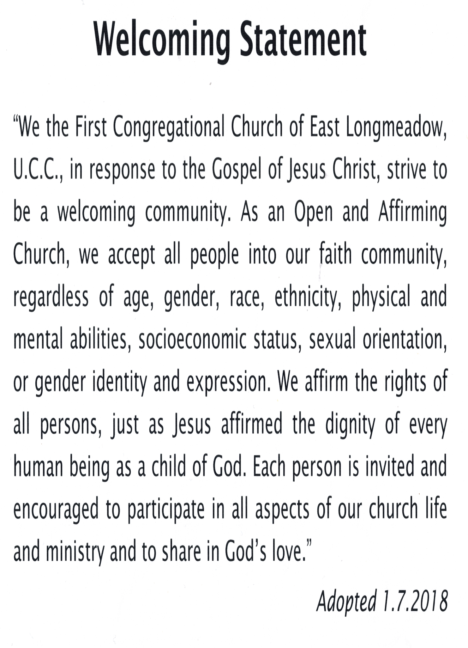
Reflect on the scope of work assigned to your pastor(s). How is their community ministry and their ministry in and on behalf of the wider church accounted for in the congregation’s expectations on their time?

4b. MISSION InSite
Comment on your congregation’s Mission Insite report with data for your neighborhood(s) or area. What trends and opportunities are shown?
The congregation demographics mirror the community’s demographics and trends. Much of the report reflects what we learned through the Partners for Sacred Places study. The trends of our town are in line with overall trends within Hampden County and the state. There is a growth in elderly population locally, which is inline with the regional, County and State demographic trends. Mission Insight Report for East Longmeadow MA. is available for review.

How do your congregation’s internal demographics compare or contrast to a) the neighborhoods adjacent to your church, and b) other neighborhoods with which your church connects? We are representative of our community of East Longmeadow.

How are the demographics of the community currently shaping ministry, or not? Nothing noteworthy at this time for trends that are impactful on our planning or programming.

What do you hear when you talk to community leaders and ask them what your church is known for?
- Christmas tree lighting ceremony
- Church that has the craft fair
- They don’t know much about our congregation

What do new people in the church say when asked what got them involved? A common response is that they felt welcomed, comfortable and curious about learning more about the church and faith representation.

5. REFERENCES

- Marcia Jackson
- Connie Sessler

Name up to three people who have agreed to serve as phone and written references. Advise the three references: “The contact information you provide may be shared publicly. Please use contact information that you feel comfortable giving to candidates so they can reach you with their questions.”

Make sure they are not members of your church but are persons who know your church well enough to be helpful to candidates seeking more information. Request a letter from each reference in answer to the four prompts below. Attach the letters (up to three) as desired.

REFERENCE 1
Mrs. Connie Sessler 15 Knollwood Drive, East Longmeadow, MA 01028
413-525-1290 sessler15@charter.net
October 20,2023
To Whom It May Concern,
From: Mrs. Connie Sessler
Re: The First Congregational Church of East Longmeadow MA, UCC
While currently a non-member my husband and I have been worshiping with this caring congregation for several months. We are longtime residents of East Longmeadow, having lived and worked here for the past 50 years. Sadly, our local home church recently closed. Having been active members there for 45+ years their closing left us in despair.
As long-time residents of East Longmeadow we knew many of the members of First Church prior to our first visit. Much to our delight we were warmly welcomed by not only those old friends, but the entire congregation. It has been our experience, these past months, that this congregation is committed to meeting the needs of it’s members, the East Longmeadow community and far beyond.
I cannot think of an area of ministry that these dedicated members don’t acknowledge and strive to fulfill.

REFERENCE 2
Marcia Jackson. Former Church Organist
413.219.9810 / marcia.jacksons-usa.com
See reference letter below:
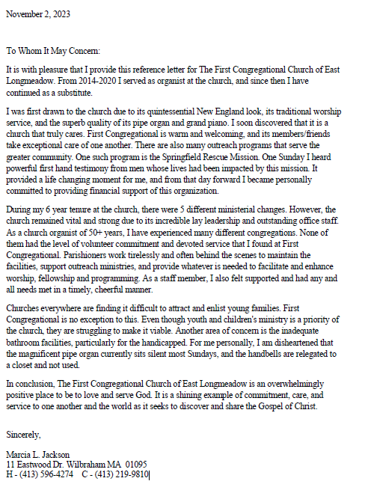

PROMPTS FOR REFERENCES
Describe some areas of strength in this church’s ministry.
Describe some areas for improvement in this church’s ministry.
Describe a significant experience you have had of this church’s ministry.
Anything else you wish to share.

6. CLOSING THOUGHTS
a. CLOSING PRAYER

b. STATEMENT OF CONSENT
c. CONFERENCE/ASSOCIATION VALIDATION

6a. CLOSING PRAYER ______

Include here any prayer or dream for the minister you imagine journeying toward you… a poem, for example, or a Scripture passage or a piece of music that is meaningful to your Search Committee:

The 4 C's of church leadership
- Calling
- Competence
- Confidence
- Character (BC suggestion)

Prayer:
My Lord God, I have no idea where I am going.
I do not see the road ahead of me.
I cannot know for certain where it will end.
Nor do I really know myself, and the fact that I think I am following your will does not mean that I am actually doing so.
But I believe that the desire to please you does in fact please you and I hope that I have that desire in all that I am doing.
And I know that if I do this, you will lead me by the right road although I may know nothing about it.
Therefore will I trust you always though I may seem to be lost and in the shadow of death.
I will not fear, for you are ever with me and you will never leave me to face my perils alone.
–Thomas Merton

Ask God to bring the right person to the attention of the team (Proverbs 14:12; Isaiah 55:8-9). 5. Pray for the search team to have God's wisdom in all the questions and information they share with the prospective pastor.

6b. STATEMENT OF CONSENT

The covenantal relationship between a church and those called by that church to serve as pastors and teachers and in other ministerial positions is strengthened when vital information is openly shared by covenantal partners. To that end, we attest that, to the best of our abilities, we have provided information in this profile that accurately represents our church. We have not knowingly withheld any information that would be helpful to candidates.
As the committee charged with the responsibility for identifying and recommending suitable new ministers for our church, we have been authorized to share the information herein with potential candidates. We understand that a candidate may wish to secure further knowledge, information, and opinions about our church. We encourage a candidate to do so, recognizing that an open exchange of relevant information builds the foundation for continuing and healthy relationships between calling bodies and persons seeking a ministry position.

Which individuals and groups in the church contributed to the contents of this Local Church Profile? (for example, church council or consistory, transition team, etc.)
- The Board of Deacons with the additional help of our moderator and members of our church cabinet.

- Additional comments for interpreting the profile:

Signed: Olan Johnston
Name / Title / Date: Olan Johnston, Moderator
First Congregational Church of East Longmeadow/UCC
April 6, 2024
6c. VALIDATION BY CONFERENCE/ASSOCIATION _____

The congregation is currently in good standing with the association / conference named.
Staff Comment:

To the best of my knowledge, ministerial history information is complete.
Staff Comment:

To the best of my knowledge, available church financial information is presented thoroughly.
Staff Comment:

My signature below attests to the above three items.

Signature:
Name / Title:
Email:
Phone:
Date:

This document is created through support to Our Church’s Wider Mission (OCWM) and is only possible through the covenantal relationships of all settings of the United Church of Christ.

“Jesus answered them, ‘Have faith in God!’” – Mark 11:22

